School of Computing, Creative Technologies, and Engineering 2021/22
Level 6 Production Project
MEETING RECORD SHEET: |  |  | Meeting  Number: 2
Student: Anupam Siwakoti |  | Student I.D.: C7227267
Date of Meeting: March 2nd, 2022 |  | Supervisor: Resham Bdr Pun
Actions agreed at previous meeting (completed or comment):
1 | Started with the research (reading books etc.,) ¨
2 | Came up with the prototype idea (Homrent) ¨
3 | Started writing literature review ¨
4 | Local setup for prototype ¨
5 | ¨
6 | ¨
Comments of student (if any):
This was the second meeting with our supervisor, I discussed with him about my prototype idea, A home renting software using all the architecture which I am going to discuss.
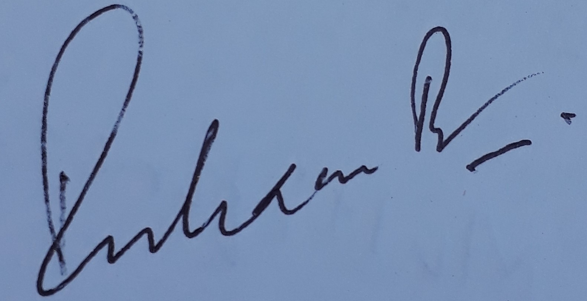
ABOVE here – student to complete before Meeting with supervisor. BELOW here – complete at the Meeting.
Next meeting (date/time): March 5th, 2022
Agreed Actions to complete before next meeting:
1 | Start the development of layered architecture
2 | Continuing writing literature review
3
4
5
6
Comments of supervisor (if any):
I accepted the prototype which he is continuing throughout the report. His literature review reflects the knowledge that he gained from what he has learned.

